|  |
| --- |
| **Karan Arora**  **R.L. Institute M: 9416974837**  **Class : XII**  **“AMINES”** |

**Assignment**

1. The IUPAC name of the following compound is :

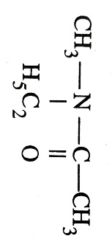

|  |  |
| --- | --- |
| a) N – Acetyl – N – methylethanamine | b) N – Ethyl – N – methylethanamide |
| c) N – Acetyl – N – methylethanamine | d) acetylethylmethylamine |

1. The formula of benzonitrile is:

|  |  |  |  |
| --- | --- | --- | --- |
| a) C6H5 CH2 – NC | b) C6H5 CH2 – CN | c) C6H5 NC | d) C6H5 CN |

1. The formula (CH3)3 C – NH2 represents a :

|  |  |  |  |
| --- | --- | --- | --- |
| a) 1 $°$ amine | b) 2 $°$ amine | c) 3 $°$ amine | d) 4 $°$ amine |

1. Which type of isomerism is shown by the following pair.

CH3 – CH2 – CH2 – CH2 – NH – CH3 and CH3 – CH2 – CH2 – NH – CH2 – CH2 – CH3

|  |  |  |  |
| --- | --- | --- | --- |
| a) position | b) Metamerism | c) tautomerism | d) functional |

1. The product of the following reaction is : CH3 – CN X

|  |  |  |  |
| --- | --- | --- | --- |
| a) CH3 – CONH2 | b) CH3 – CH2 – NH2 | c) C2H6 | d) CH3 – NH – CH3 |

1. When a haloalkane is heated with KCN in aqueous ethanoic solution, the product formed is :

|  |  |  |  |
| --- | --- | --- | --- |
| a) alkyl nitrite | b) nitroalkane | c) alkyl nitrile | d) carbylamine |

1. What is ‘X’ in the following reaction?

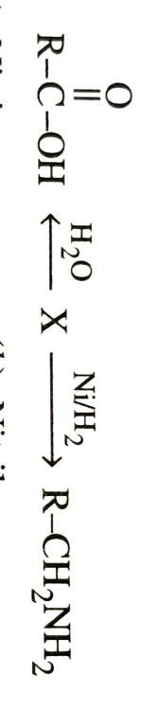

|  |  |  |  |
| --- | --- | --- | --- |
| a) Nitrite | b) Nitrile | c) Amine | d) Isonitrile |

1. Amine that cannot be prepared by Gabreil phthalimide synthesis is :

|  |  |  |  |
| --- | --- | --- | --- |
| a) Aniline | b) Benzylamine | c) tert-butylamine | d) isobutylamine |

1. Which of the following reactions will not give a primary amine?

|  |  |
| --- | --- |
| a) CH3 CONH2 | b) CH3 CN |
| c) CH3 NC | d) CH3 CONH2 |

1. Which of the following amine has highest boiling point?

|  |  |
| --- | --- |
| a) pentanamine | b) 2 – methylbutanamine |
| c) 2 , 2 – dimethylpropanamine | d) 3 – methylbutanamine |

1. Which of the following is most basic?

|  |  |  |  |
| --- | --- | --- | --- |
| a) Benzylamine | b) Aniline | c) Acetanilide | d) p-nitroaniline |

1. Which of the following compound is least basic?

|  |  |  |  |
| --- | --- | --- | --- |
| a) NH3 | b) CH3 – NH2 | c) C6H5 – NH2 | d) C2H5 – NH2 |

1. The correct decreasing order of basic strength of the following species is H2O , NH3 , OH – , (where OH and NH2 are attached to alkyl group).

|  |  |
| --- | --- |
| a) > OH – > NH3 > H2O | b) OH – > > H2O > NH3 |
| c) NH3 > H2O > > OH – | d) H2O > NH3 > OH – > |

1. Identify ‘A’ in the following reaction sequence :

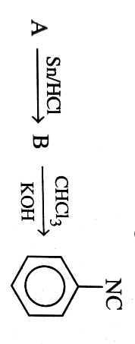

|  |  |  |  |
| --- | --- | --- | --- |
| a) | b) | c) | d) |

1. Which of the following exists as Zwitterion?

|  |  |  |  |
| --- | --- | --- | --- |
| a) p-Aminobenzoic acid | b) Sulphanilic acid | c) Benzene sulphonic acid | d) p-Aminophenol |

1. The amine that reacts with NaNO2 + HCl to give yellow oily liquid is :

|  |  |  |  |
| --- | --- | --- | --- |
| a) ethylamine | b) diethylamine | c) isopropylamine | d) 2 $°$ butylamine |

1. Which of the following will not undergo diazotization?

|  |  |  |  |
| --- | --- | --- | --- |
| a) m-Toluidine | b) aniline | c) p-Aminophenol | d) Benzylamine |

1. The Sandmeyer reaction of diazonium salt is a replacement of N2 by :

|  |  |  |  |
| --- | --- | --- | --- |
| a) Halogen | b) Hydroxy group | c) coupling | d) hydrogen |

1. Which of the following will not show coupling reaction with benzene diazonium chloride?

|  |  |  |  |
| --- | --- | --- | --- |
| a) Aniline | b) phenol | c) 2-Naphthol | d) Benzyl alcohol |

1. Which of the following does not react with Hinsberg’s reagent?

|  |  |  |  |
| --- | --- | --- | --- |
| a) C2H5 – NH2 | b) (C2H5)2 – NH2 | c) (C2H5)3 N | d) CH3 – NH2 |

1. In the following reaction, ‘X’ is :

X $\underset{→}{ Bromination }$ Y $\underset{→}{ {NaNO}_{2}/HCl }$ Z $\underset{→}{ Boiling , C_{2}H_{5}OH }$ Tribromobenzene

|  |  |  |  |
| --- | --- | --- | --- |
| a) Benzoic acid | b) Salicylic acid | c) Phenol | d) Aniline |

1. The control use of biocontrol agents, such as live organisms or enzymes from organisms to produce products and processes for human welfare is called as :

|  |  |  |  |
| --- | --- | --- | --- |
| a) | b) | c) | d) |

1. EFB stands for :

|  |  |
| --- | --- |
| a) | b) |
| c) | d) |

1. The definition of biotechnology given by EFB encompasses:

|  |  |
| --- | --- |
| a) Traditional biotechnology | b) Modern molecular biotechnology |